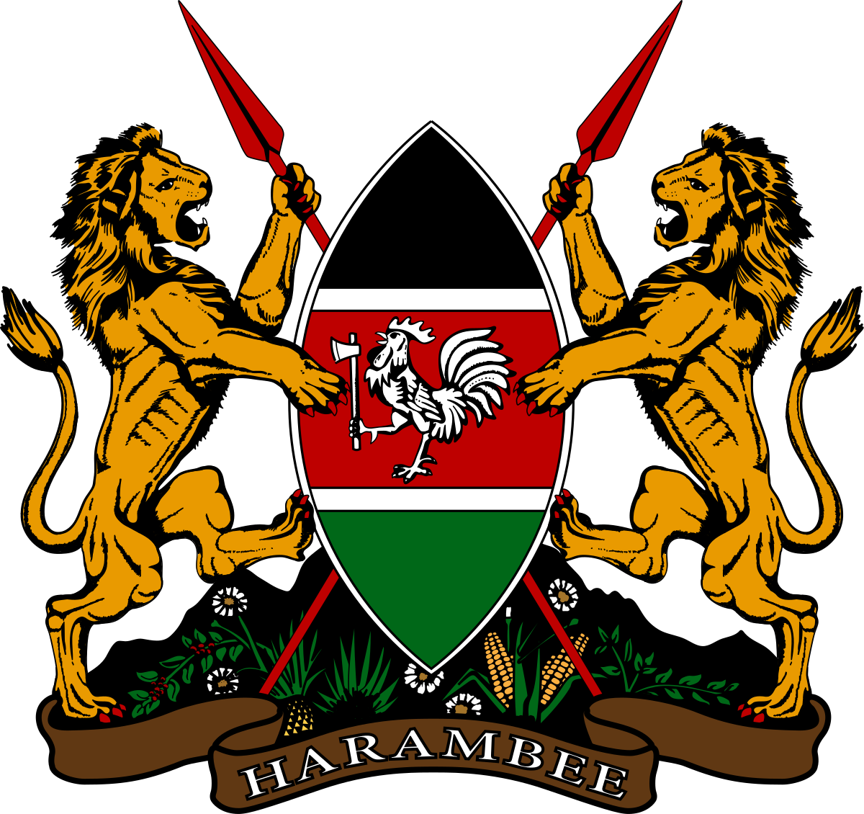

**REPUBLIC OF KENYA**

**THE JUDICIARY**

**THE JUDICIARY**

**PAY MONTH JUL-2022**

STAFF ID 80853

NAME Ray Njire Ngariama

UNIT Court Operations

NATIONAL ID: 34812227

KRA PIN: A013022191F

NSSF NO: 0

NHIF NO: 15944800

AGE: 25 Y, 1 M

POSITION Court Assistant II

GRADE JSG 9

PAYPOINT: Kaloleni Law Courts

===============================================================

**EARNINGS**

BASIC PAY 29,400.00

Rental House Allowance 20,000.00

Transport Allowance 12,000.00

**GROSS PAY 61,400.00**

LESS:

PENSION RELIEF 2,646.00

INSURANCE RELIEF 195.00

TAXABLE AMOUNT 58,754.00

===============================================================

**DEDUCTIONS**

P.A.Y.E 9,814.55

N.H.I.F. 1,300.00

Provident Fund (Auto) 2,646.00

TOTAL DEDUCTIONS 13750.55 ===============================================================

**NET PAY 47,639.45**

**Equity Bank Limited: Kengeleni KES: 47639.45**

**1140172859049**

===============================================================

TAX CHARGED 12,214.55

PERSONAL RELIEF 2,400.00

P.A.Y.E 9,814.55

**EMPLOYER PENSION**

Provident Fund (Auto) 5,292.00

Jul 22, 2022 5:50 PM